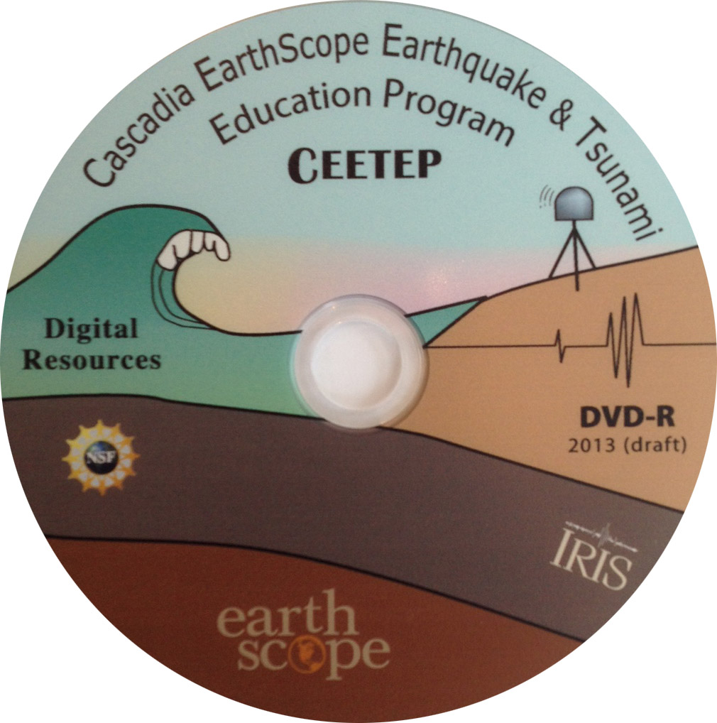
CEETEP – Related Digital Resources
The resources on the CEETEP DVD and website include many items developed by or in collaboration with other organizations. Here we overview some of the partner and related organizations so you can access them directly.
1. IRIS – Integrated Research Institutes for Seismology
Many IRIS educational resources. In particular:
Animations on plate tectonics, seismology, GPS, earthquakes, and tsunami are added periodically (many of the best existing ones are on your CEETEP DVD and USB drive).
We will sign you up to receive IRIS Teachable Moments. These are earthquake notices send out within 24 hours of all significant earthquakes. Let your colleagues know so they can sign up too.
2. UNAVCO – runs the >1100 GPS stations for EarthScope
Find your closest GPS station using the Plate Boundary Observatory (PBO) network map. Zoom in and then click on station of interest. A small box will open up. Click on the station name to go to the station website with data and photos.
There is also a Velocity Viewer that shows velocity arrows, but not all the stations show automatically. You can select at the bottom to see all, but it is better to do after you zoom into the general area of interest.
3. EARTHSCOPE
EarthScope’s site has some resources but UNAVCO and IRIS have more.
4. TOTLE – Teachers on the Leading Edge
Many of the same resources available on your TOTLE DVD. TOTLE was a previous K-12 teacher professional development program funded by EarthScope for Pacific Northwest. Great place to point colleagues to if you want to point colleagues towards resources. In particular, if you cannot take your learners into the field but still wish to show them what is seen in the field, there are Virtual Field Environments for Oregon and Washington tsunami sites. You can find the Niawiakum River site that we visited is the Southwest Coastal Washington, Niawiakum Site #4. (The VFEs are also on your TOTLE DVD.)
5. Red Cross Emergency Planning Guide
Resources to develop an emergency plan for your family or workplace.
6. SCEC – Southern California Earthquake Center
The SCEC is funded by the National Science Foundation and the USGS to develop a comprehensive understanding of earthquakes in Southern California and elsewhere, and to communicate useful knowledge for reducing earthquake risk. SCEC is part of the Earthquake Country Alliance, a public-private partnership of people, organizations, and regional alliances that work together to improve preparedness, mitigation and resiliency.
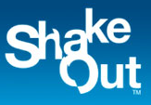
7. SHAKE OUT EARTHQUAKE DRILLS
Great ShakeOut Earthquake Drills are an annual opportunity for people in homes, schools, and organizations to practice what to do during earthquakes, and to improve preparedness. A collection of ShakeOut-related visualizations.

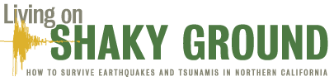
8. RCTWG – Redwood Coast Tsunami Workgroup
RCTWG is an interagency group working to reduce earthquake and tsunami hazards and coordination mitigation activities on California’s North Coast. It has been a leading organization in grassroots action and initiated the development of the Living on Shaky Ground resources.
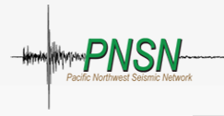
9. PNSN – Pacific Northwest Seismic Network
PNSN monitors the occurrence of Episodic Tremor and Slip (ETS) events throughout Cascadia. You can see maps of tremor on their site. Use the sliders at the bottom to pick the period of interest. In order to follow the PNSN commentary about a given episode, visit the event overview and blog page.
10. USGS – United States Geologic Survey
National Earthquake Information Center has information about and maps of earthquakes around the world. Did you feel it? – if you feel an earthquake, input data about the shaking you felt there. This is valuable citizen science that helps USGS research correctly model expect shaking for future quakes. Earthquakes for Kids has activities.
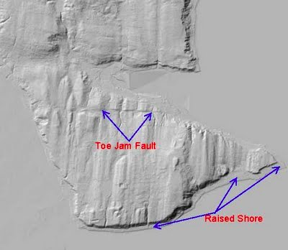
11. LIDAR – very high-resolution topographic images that greatly aid in landslide and fault scarp identification
Open Topography has an image library from around the country that includes many shaded relief images in Google Earth format. For state-specific images, you go to the Puget Sound Lidar Consortium and Oregon Lidar Consortium.
12. Oregon Resources
Oregon Tsunami Clearinghouse - maps and apps and more
13. Washington Resources
Tsunami evacuation maps (same page has a number of other tsunami resources)
Tsunami inundation maps
Interactive maps including geologic formations, seismic scenarios, and natural hazards.
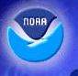
14. NOAA – National Oceanic and Atmospheric Administration
NOAA runs the tsunami warning system for the USA. Thus distant tsunami warnings come through the NOAA warning system as well as educational resources.
15. Native American teaching resources (not hazards but great anyhow)
WA OSPI Environmental & Sustainability Enhanced Lessons
Indian Reading Series: Stories and Legends of the Northwest
16. Resources for children (particularly for younger children)
FEMA Disaster Master and Emergency Backpack activities
FEMA Helping Children Cope with Disaster
USGS Earthquakes for Kids has a variety of earthquake activities/info
WA Emergency Management Division Tsunami Survival Challenge
Tsunami: Know What to Do NOAA cartoon with crabs learning about tsunami and preparedness
Tommy Tsunami coloring book, tsunami info worksheet and Kids Hazard Quiz

